
https://app.powerbi.com/view?r=eyJrIjoiOWYwM2U3N2MtMDY2MC00YTVjLWE1OGUtNjQ4ZjYyNDIxYTllIiwidCI6IjU1MDNhYWMyLTdhMTUtNDZhZi1iNTIwLTJhNjc1YWQxZGYxNiIsImMiOjR9

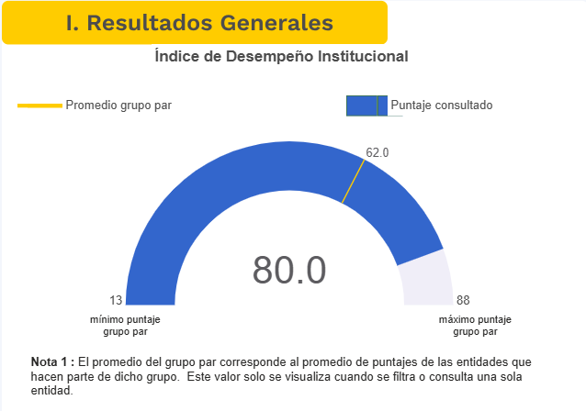

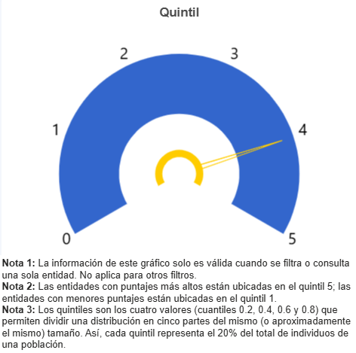
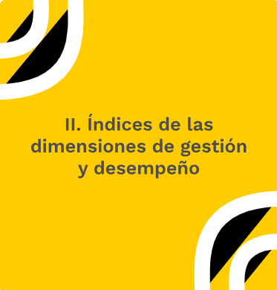

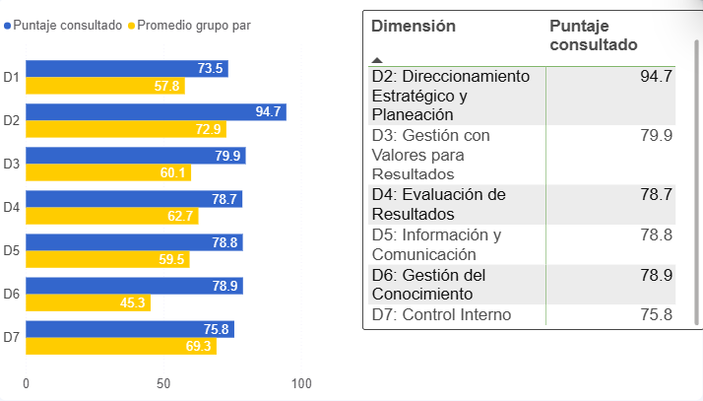

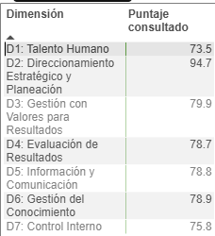

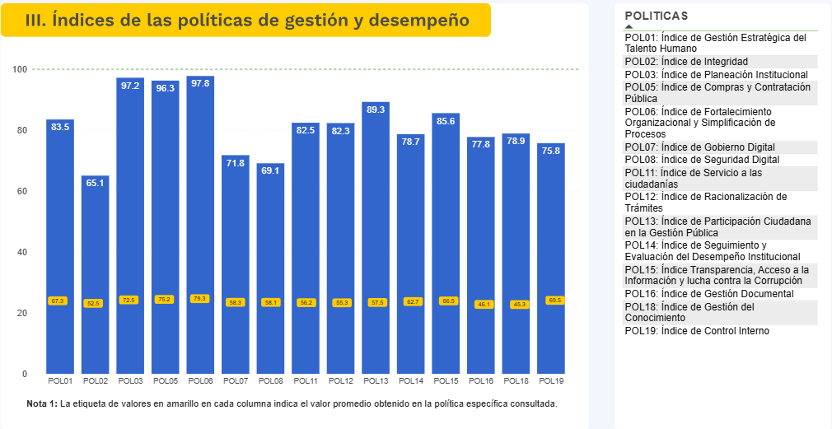


https://app.powerbi.com/view?r=eyJrIjoiOWYwM2U3N2MtMDY2MC00YTVjLWE1OGUtNjQ4ZjYyNDIxYTllIiwidCI6IjU1MDNhYWMyLTdhMTUtNDZhZi1iNTIwLTJhNjc1YWQxZGYxNiIsImMiOjR9

